Instructions for Importing Unformatted Bibliographies into EndNote

1. Open the unformatted bibliography in MS Word. Ensure that each record, which represents a bibliographic reference, begins on a new line. This can be ensured by viewing “all nonprinting characters” in MS Word; there should be a paragraph mark after each record.

Here is a screenshot of what this should look like:

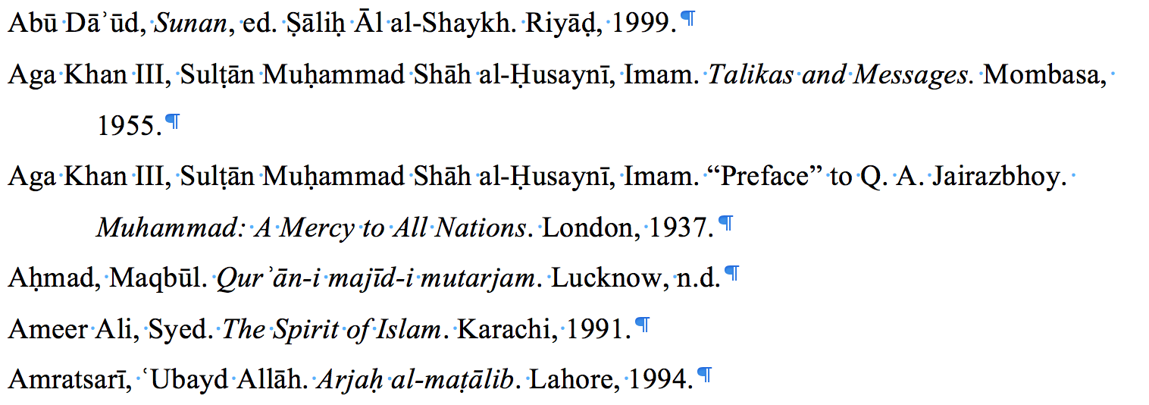

Also ensure that the records are not numbered and don’t have leading whitespace in the records. [This website](http://www.textfixer.com/tools/remove-white-spaces.php) can be used to remove whitespace from text and [this website](http://alphabetizer.flap.tv/remove-numbers-from-beginning-of-each-line.php) can be used to remove numbering. Often, whitespace elimination is needed after the latter website is used to eliminate numbering.

1. Run the latest version of the “TagUnformattedBib” macro which has been provided. This macro will tag each record with:
   1. A tag which indicates its reference type (e.g. “DT:BK” for book)
   2. An “x--” tag which indicates the start of a new record

Here is a screenshot of a tagged file:

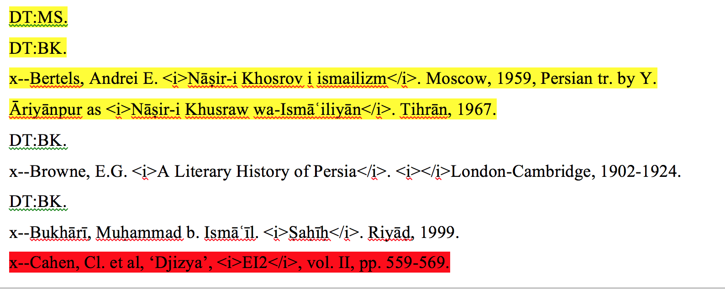

1. The macro highlights records which failed to be recognized in red. These records need to be identified manually by adding “DT:BK.”, “DT:JA.” or “DT:MS.” on a separate line above the record. The macro also highlights conflicts in reference type recognition in yellow. These must also be fixed by getting rid of the tag which the reference does not correspond to.

Here is a screenshot of a fixed version of the same file, which is ready to be imported into EndNote (the highlighting doesn’t need to be removed by the user):

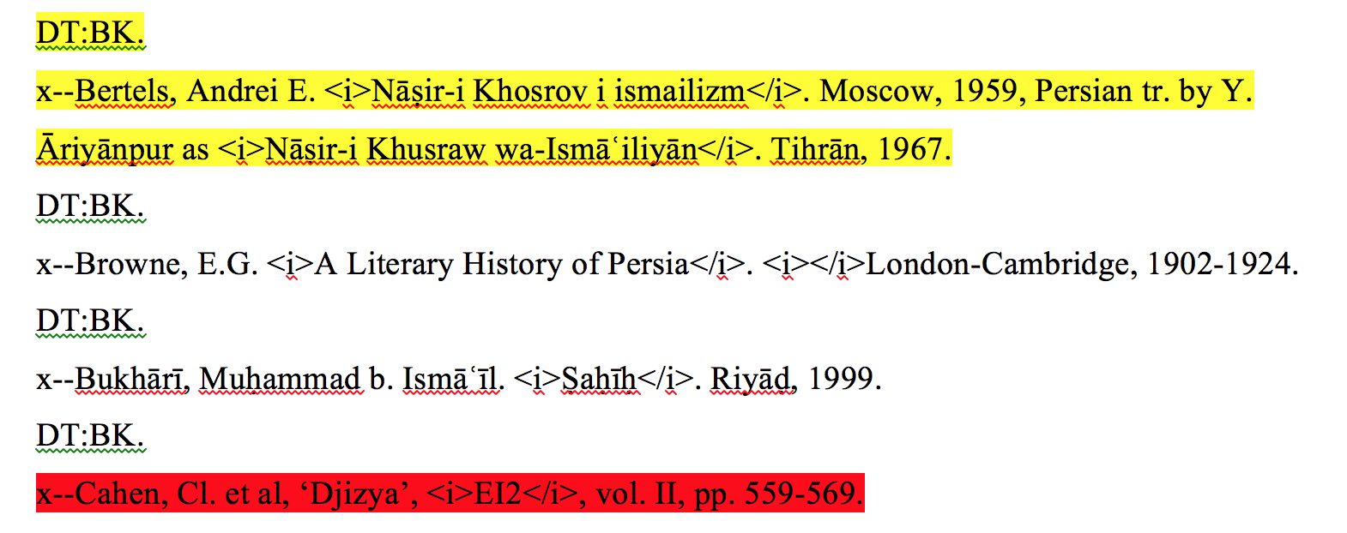

1. Once the word document is ready to be imported into EndNote, copy all of its contents and paste them into a new text (.txt) file. Do not use “Save As” to export the document as a text file, use the copy-paste instead.
2. Import the newly created text file into EndNote. Ensure that the “ImportUnformattedBib” import filter is selected in the import options. This can be done by clicking “File -> Import” in EndNote and selecting the filter from the “Options” tab. (see screenshot below)

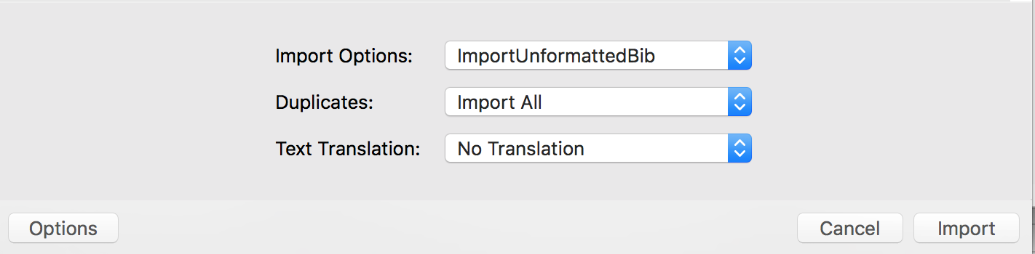

1. The records which the import filter fails to recognize will be imported as references with all the information added to the “Notes” field instead of the respective fields where they belong. (see screenshot below)

